|  |  |  |  |
| --- | --- | --- | --- |
| 1 | | 24,744 | |
| **NUMERO DE FRONTERAS** | | **ENERGIA AGREGADA** | |
|  | | | |
| 10,806,295 | 20 | | 494,880 |
| INGRESO 2020 | DÍAS CERTIFICADOS 2020 | | ENERGIA RESPALDADA 2020 |
|  | | | |
| 39,976,167 | 69 | | 1,707,312 |
| INGRESO 2021 | DÍAS CERTIFICADOS 2021 | | ENERGIA RESPALDADA 2021 |

**HISTORICO REINTEGRO DDV**

|  |  |  |
| --- | --- | --- |
|  | **2020** | **2021** |
| **ENE** | - | 13.26 |
| **FEB** | - | 15.11 |
| **MAR** | - | 7.57 |
| **ABR** | - | 1.22 |
| **MAY** | - | 2.83 |
| **JUN** | - | - |
| **JUL** | - | - |
| **AGO** | - | - |
| **SEP** | - | - |
| **OCT** | - | - |
| **NOV** | - | - |
| **DIC** | 10.81 | - |

**Los valores de la tabla están en millones de COP**



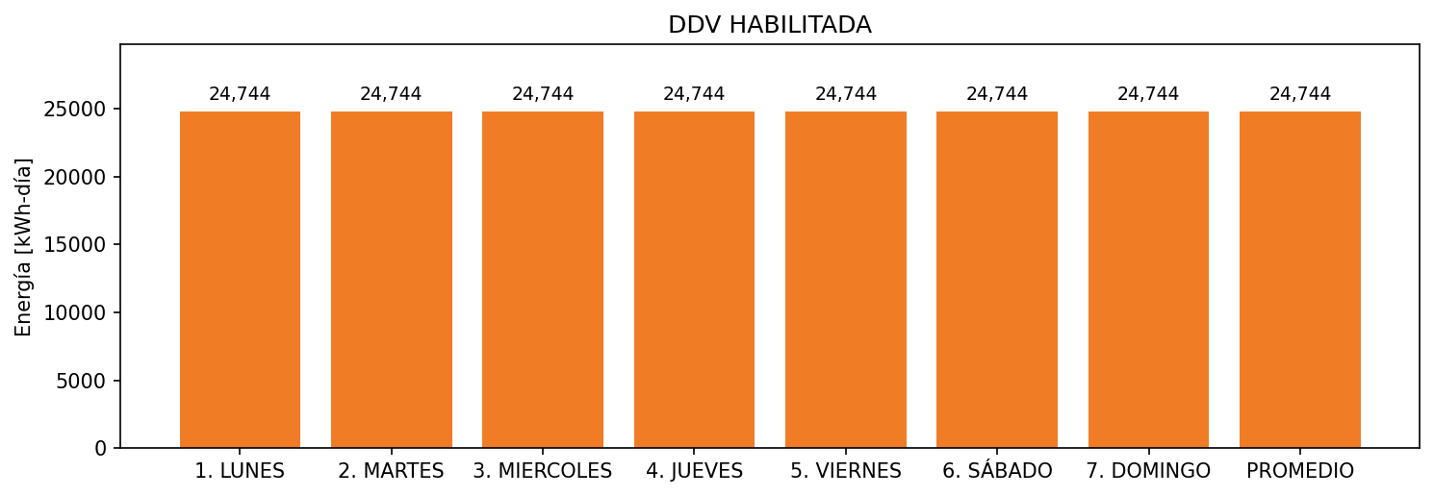

|  |  |  |  |  |  |  |  |  |  |
| --- | --- | --- | --- | --- | --- | --- | --- | --- | --- |
| **FRONTERA** | **COD SIC** | **FRT DDV** | **TIPO DDV** | **PROMEDIO** | **PRÓXIMA ACTUALIZACIÓN** | **MARGEN DE ERROR** | **ÚLTIMA PRUEBA DDV** | **DÍAS PARTICIPACIÓN** | **FECHA REFERENCIA PRÓXIMA PRUEBA DDV** |
| INDUSTRIAL DE GASEOSAS S.A. - INDEGA S.A. | Frt00670 | Frt38600 | GPE | 24,744 | 2023-04-15 | NO APLICA | 2020-11-24 | 89.0 | 2021-12-17 |